For set up Grid run the yaml file. 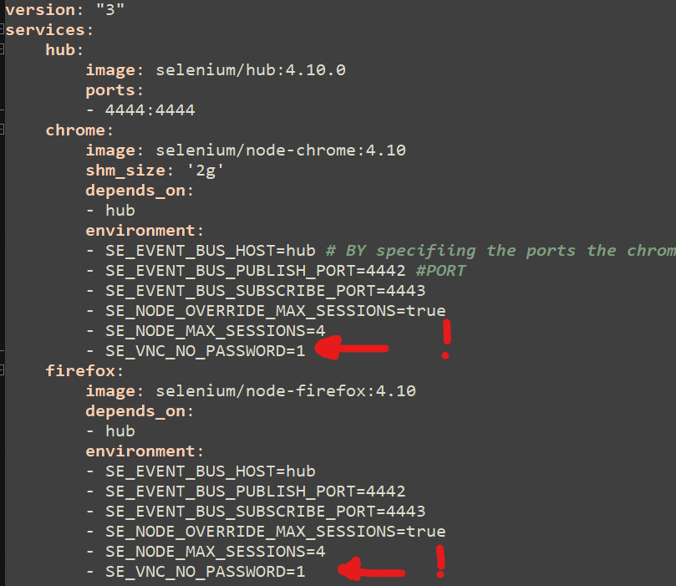

hub - is the container wich represent Grid by using image: selenium/hub:4.10.0